PRENATAL ARRAYS USER GUIDE

Array Analysis
SNP array is a technique which screens the whole genome to detect copy number changes (unbalanced gains/duplications and losses/deletions of genetic material) which in a prenatal setting may be contributing to a fetus’s phenotype. In addition, SNP arrays can detect absence of heterozygosity, which in certain chromosomal regions (such as Prader-Willi syndrome) and uniparental disomy (such as maternal UPD14 - Temple syndrome) can also be pathogenic.
The Leeds Genetics Laboratory uses a SNP (single nucleotide polymorphism) array platform to perform microarray testing on eligible prenatal samples. The wet laboratory work is undertaken by the Northern Genetics Service in Newcastle with the analysis, reporting and issuing of prenatal results all being performed by the Leeds Genetics Laboratory.

Cohort eligible for testing
It is important that any patient referred for SNP array testing is appropriately consented and counselled about the technology including its limitations, target turnaround times, and reporting arrangements including incidental findings.

Referrals should be submitted using the joint referral card which can be downloaded from this website.
All referrals are initially tested by QF-PCR for sexing and rapid aneuploidy assessment for chromosomes X,Y,13,18 and 21.

If the QF-PCR result is normal prenatal arrays are performed in the following cases unless stated on the referral form by the referring clinician:

1) A pregnancy with an abnormal ultrasound scan
- A pregnancy with an increased NT of >3.5mm
- Other specific clinician requests
- A pregnancy in a family known to carry a clinically significant genomic imbalance detected pre- or postnatally by array or another molecular method.

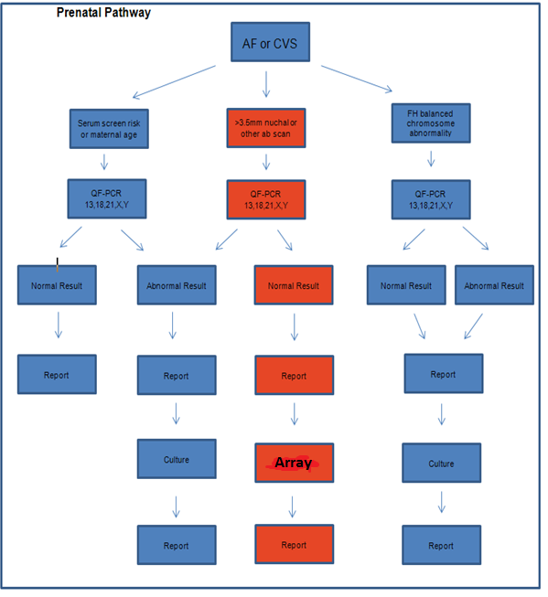

Specimens required for QF-PCR, SNP array and karyotype to be performed:
- Amniotic Fluid - Minimum 15-20ml
- CVS - 5 fronds

Parental bloods will be requested by the laboratory if required

Turnaround Times (TAT)
Our professional body the Association for Clinical Genetic Science (ACGS) issues best practice guidelines which define the recommended TAT for prenatal karyotyping as 95% of cases reported within 14 calendar days of sample receipt. At present it is not feasible to turn prenatal arrays around within this timeframe, although all efforts will be made by the lab to work towards achieving this.
The lab will endeavour to report a prenatal SNP array result within 21 days of sample receipt for a first line array, or within 28 days for an array performed after karyotyping due to an abnormal result. This will include any confirmatory studies necessary in the event of finding a pathogenic imbalance.
Where it is necessary to analyse parental samples for confirmation/clarification purposes, an interim prenatal SNP array report will be issued and a final report when any necessary parental studies are completed.

Suboptimal Samples
Where DNA quality from uncultured sample is unsuitable for SNP array analysis, it will be necessary to extract DNA from cultured cells. This will delay reporting times as DNA extraction can only take place when cultures are ready (about 10-14 days from receipt).

Interpretation and Reporting
The purpose of a prenatal array in an ongoing pregnancy is to ascertain whether there is a genetic imbalance present that is clinically significant with respect to the features detected on antenatal scan or whether a familial imbalance is present in a fetus.

Interpretation for ongoing pregnancies
1) Imbalances will only be reported if they are interpreted as likely to be clinically significant to the fetus in relation to the supplied USS features. Clinically significant findings will include recognised microdeletion and duplication syndromes, as well as other imbalances where the literature details association with significant problems.
2) Neurosusceptibility loci have variable expression and penetrance and therefore the phenotype of an individual carrying one of these imbalances may vary from within normal limits to developmental delay and autism. As phenotypic certainty cannot be offered and in line with national consensus only a limited number of these loci that are associated with an increased incidence of anomalies detected on scan will be reported.
3) Due to the increased resolution of the screening there may be occasional unexpected incidental copy number imbalances detected which are unrelated to the scan findings. Incidental findings will be discussed with the Obstetrician, Clinical Geneticists and laboratory staff on a case to case basis and will only be reported if they will have significant implications for the fetus or other family members and by reporting them there will be a health benefit to these individuals.
4) Benign imbalances or imbalances classified as variants of uncertain significance will not be reported or validated.

Interpretation for non-viable / terminated pregnancies
If a pregnancy is no longer ongoing (after discussion with obstetric team/clinical geneticist) and on analysis an imbalance is detected that may either:
- Have contributed to the phenotypic features of the fetus or the demise of the pregnancy, or
- Be clinically significant for other family members (neurosusceptibility loci, incidental findings).
These findings will be reported.

Confirmation and follow-up
If a clinically significant imbalance is detected further confirmation studies will be performed. These may take the form of FISH studies, Q-PCR (different to QF-PCR) studies, MLPA, karyotyping or another technique as appropriate.
Parental studies will be undertaken to determine whether the imbalance has arisen de-novo or has been inherited where appropriate.
These studies will add extra days to the reporting time.

Reports
Reports are issued to the referring clinician. Complex results may also be discussed with a Clinical Geneticist.

Limits to SNP array technique and reporting restrictions
- SNP arrays will not detect all genetic abnormalities
- SNP Arrays cannot detect balanced chromosome rearrangements such as reciprocal translocations and inversions. Karyotyping will be carried out for patients suspected of these abnormalities.
- SNP arrays have limited sensitivity for the detection of mosaicisim.
- SNP arrays cannot detect mutations. Requests for specific mutation testing can be made to the laboratory.
- Carrier status for recessive disorders may not be reported.
- Anomalies may occur which cannot always be recognised or properly interpreted.
- Not all imbalances will be reported (as detailed above). Imbalances will only be reported if they are interpreted as likely to be of clinical significance to the fetus or have a clinically actionable consequence for the fetus or family in the future. Some unreported imbalances may become clinically significant postnatally.
- Confined placental mosaicism cannot be excluded when DNA is extracted entirely from the cytotrophoblastic cells of chorionic villi.

Technical Details:
SNP Array platform: Whole Genome Infinium CytoSNP-850K v1.2 Illumina BeadChip array.
Analysis software: BlueFuse Multi v4.4. Genome Build: GRCh37.
Average backbone resolution: approximately 50kb. Average targeted gene resolution: approximately 10kb.

Further Information
This document is designed to provide current information about the local policy regarding prenatal arrays. The local policy is subject to amendment following publications or any recommendations set by the Royal College of Obstetricians and Gynaecologists and the Association for Clinical Genetic Science (ACGS) Quality Committee (for best practice guidelines). Users will be informed of any major changes in policy.
Should you require any further information please contact the laboratory directly.

