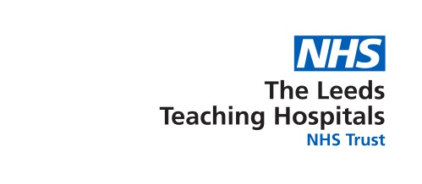

Fare Processing Notice (FPN)
Regional Health and Social Care Employees

Background

Owing to the Covid-19 pandemic, the Leeds Teaching Hospitals NHS Trust has been tasked with the delivery of the Covid-19 vaccination program, for all Health and Social care employees within the Leeds and West Yorkshire region.

Trust have a legal basis to collate, store and process personal information on a daily basis for the purposes of preventive or occupational medicine, for the assessment of the working capacity of the employee, medical diagnosis, the provision of health or social care or treatment or the management of health or social care systems, or the process is necessary for the performance of a task carried out in the public interest.

What information we will collect about you?

Your employer will provide the Trust with your NHS Email address to enable the Trust as the delivery organisation to facilitate your Covid-19 vaccination.

The Trust will contact you using your NHS email account, providing you with a link to access and book your Covid-19 vaccination. The Trust will use a secure web based platform service, to manage the booking of your appointment.

In order to fulfil the Government’s statutory requirements, on the day of your vaccination, the Trust will collect personal, special and risk category information about you via your Covid-19 vaccination consent form.

How your personal information is used?

In order for Trust to perform a task carried out under the public’s interests, it is necessary for Trust to collate and process all of your relevant information including the vaccine you received. This will ensure sure that:
- The way in which you receive care and management of the vaccine is correct,
- The right information is available if you see another doctor,
- Healthcare staff have the information they need to be able to look at and improve the quality and type of care you receive.

Who will we share personal information with?

Everyone working within the NHS has a legal duty to keep information confidential. Similarly, anyone who receives information from us has a legal duty concerning your confidentiality. We will share your information with your GP’s electronic care systems.

How your personal information will be used to improve the NHS

Your information will also be used to help us manage the NHS and protect the health of the public by being used for:
- Make sure our service can meet people’s needs in the future,
- Prepare statistics on NHS performance for management and planning of local government,
- Review the service we provide to make sure it is of the highest standard and quality.

How can you access your person records?

Your information will be available to access via your GP practice. You will be required to request your information through a Subject Access Request (SAR), this is a free service.

Retention

The Trust will hold your information on the electronic database in accordance with the NHS Digital retention policy.

Data Controller:
The Data Controller responsible for keeping you information confidential is:
The Leeds Teaching Hospitals NHS Trust
St James University Hospital
Trust Headquarters, Beckett Street, Leeds, LS9 7TF
Telephone: 0113 243 3144

The Trusts Data Protection Officer is:

Johnny Chagger

Notification
The Data Protection act 2018 required organisations to lodge a notification with the Information Commissioner to describe the purpose for which they process personal information, these details are publically available from:
Information Commissioner’s Office
Wycliffe House, Water Lane, Wilmslow, SK9 5AF
Telephone: 0845 630 6060 Website: www.ico.gov.uk

