**New Copan eSwab for Bacteriology samples.**

[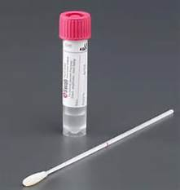](http://www.bing.com/images/search?q=eswab&view=detailv2&adlt=strict&qpvt=eswab&id=487F9AF2D8F92EE141939E5ECC3D42BE3F579370&selectedIndex=2&ccid=CY/vDryG&simid=608042176142510279&thid=OIP.M098fef0ebc86a112ff747cd16643edf6o0)[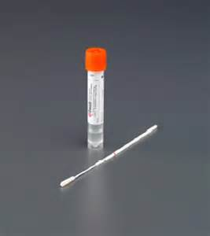](http://www.bing.com/images/search?q=images+copan+eswab&view=detailv2&adlt=strict&qpvt=images+copan+eswab&id=651ADD53B951F12B669EF9705504F6572F92DCAA&selectedIndex=5&ccid=kn7UuHmd&simid=608052338034281094&thid=OIP.M927ed4b8799df6181d2e67793dedf015o0)

**IMPORTANT:**

**DO NOT USE FOR MRSA SCREENING**

**MRSA SCREENING PACKS CAN BE ORDERED FROM PATHOLOGY SUPPLIES IF NEEDED**

***Orange cap Liquid Amies Single Swabs***.

Use for Ear swab culture and urethral swabs only.

***Pink cap Liquid Amies Single Swabs***.

Use for Microbiology Culture and Sensitivity (MMCS) Investigations

Collection from: wound, skin, nose, throat, eyes, mouth, vaginal

  

Break swab shaft at coloured breakpoint and leave swab in tube

Unscrew cap and insert swab into the liquid in the tube.

Remove swab from pack and take sample

3 

**REMEMBER:**

* **Liquid must remain in the tube - this is what is tested**
* **White swab must be in the tube - this is how we know a sample has been taken**
* **Always ensure samples are labelled fully.**

Label tube with full patient ID or OrderComms label placed vertically on tube.

Screw the cap tight onto the tube