July 2023

Dear Colleague,
Re: Genetic testing on fetal tissue (indication codes R22 and R318)

As a result of the NSHE reconfiguration of genomic testing in England, all genetic laboratories are now required to deliver testing according to the National Genomic Test Directory https://www.england.nhs.uk/publication/national-genomic-test-directories/. The aim is to drive standardisation and increase equity of patient access. Only tests that fulfil the rare and inherited eligibility criteria are funded.
We are writing to inform you that from 4th September 2023, the North East and Yorkshire GLH will no longer accept fetal tissue samples for testing that do not comply with the eligibility criteria set out in the National Genomic Test Directory.

The majority of fetal tissue referrals undergo QF-PCR and/or SNP microarray testing to determine if there is a underlying genetic cause for fetal loss or abnormality. The testing methodology used may vary and will depend on referral reason and individual laboratory pathways.

The standard turnaround targets set by NHSE for testing is 42 days. Reports may be returned quicker however due to capacity issues within the genetics laboratories, patients should be counselled that result may take significantly longer.

The two main clinical indications for referral are:

R318 Recurrent miscarriage with products of conception available for testing
This indication is relevant to recurrent miscarriage with products of conception available for testing – defined as three or more miscarriages.
Local agreement, based on ongoing national discussions regarding eligibility, is that samples will be accepted for tests after three miscarriages, even if these are not consecutive. There is no change to current practice. Samples sent for testing after one or two miscarriages will not be processed.

R22 Fetus with a likely chromosomal abnormality (for non- recurrent pregnancy losses)
This indication is relevant to:
- fetal loss, termination of pregnancy or miscarriage where there are fetal abnormalities suggestive of an underlying chromosome abnormality OR
- third trimester intrauterine death or stillbirth in the absence of other likely causes
First and second trimester samples (up to 27+6 gestational weeks) will only be accepted if fetal abnormalities are present, diagnosed on antenatal ultrasound or post-mortem appearances of the fetus. If no fetal abnormalities are evident, the sample will not be processed. This is a change to current practice.
For third trimester stillbirth, samples will not be accepted for testing where an alternative cause of intrauterine death is the most likely contributor, for example placental abruption or intra-uterine infection. This is a change to current practice.

In order for the laboratory to ensure that referrals meet the appropriate criteria, all fetal tissue samples must be accompanied by the GLH Feto-maternal request form which can be downloaded here:
https://ney-genomics.org.uk/wp-content/uploads/2022/02/411.030-Prenatal-form-v2.0web.pdf

The information required in order to activate testing is detailed below

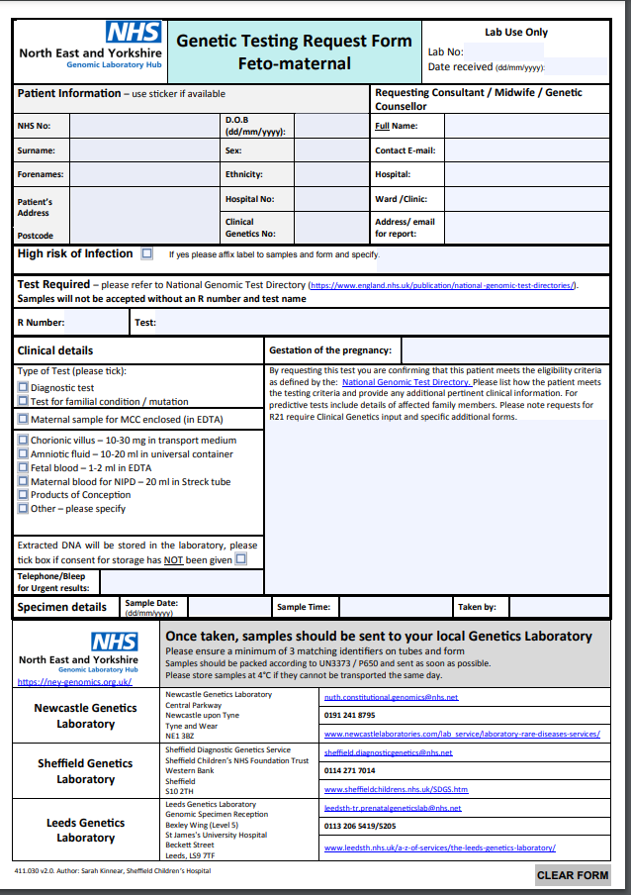

Test indication code (R22 or R318)

Gestation

Include relevant clinical details to evidence test eligibility, eg:
- Details of any congenital abnormalities – state whether on ultrasound or diagnosed after birth
- Confirm that there no known reasons for 3rd trimester intrauterine death.
- State number of confirmed miscarriages for R318 referrals.
Indicate if consent for storage has NOT been given

Tests will not be activated if the correct form is not used and the required information is not provided. Instead, extracted DNA will be stored (unless the referrer has indicated that consent has not been given) and the referrer notified that no genetic tests will be carried out as the sample did not meet the required criteria.

We are aware that at present, national maternity and bereavement guidelines may not be fully aligned with the guidance in the NHSE Genetic Test Directory. Feedback has been provided to the national teams in all stakeholder organisations and we will continue to highlight these differences. The GLHs are unable to deliver testing outside of the contents of the test directory, even when other specialty guidelines may differ.

Please ensure that you gain parental consent for all genomic investigations. Please also ensure that patients are aware of the above criteria, especially when testing is not indicated.

If you have any questions regarding the change in service please do not hesitate to contact myself (ruth.charlton1@nhs.net) or the prenatal scientific lead for your local genetics laboratory:

Newcastle Genetics Laboratory: Shaun Haigh shaun.haigh@nhs.net
Leeds Genetics Laboratory: Beth Wild bethany.wild@nhs.net
Sheffield Genetic Diagnostic Service: Emma Shearing emma.shearing@nhs.net

Yours faithfully,

Dr Ruth Charlton
Consultant Clinical Scientist
NEY GLH Scientific Lead for Rare Disease

Dr Jennifer Campbell
Consultant Clinical Geneticist, Leeds Teaching Hospitals NHS Trust
SRO NEY GMSA Perinatal Genomics Transformation Project

Dr Kelly Cohen
Consultant in Obstetrics and Fetal Medicine, Leeds Teaching Hospitals NHS Trust
SRO NEY GMSA Perinatal Genomics Transformation Project

