Cancer Strategy- The 8 Big Themes
Leeds Teaching Hospitals Trust is writing a cancer strategy to agree our ambitions for the next 5 years. Staff have shared their experience and ideas about what the big themes of the strategy should be. A team of staff from the Trust have looked at this and think there are 8 big themes that should be in the strategy. However, we need the experience of patients who have used Trust cancer services to get this right.
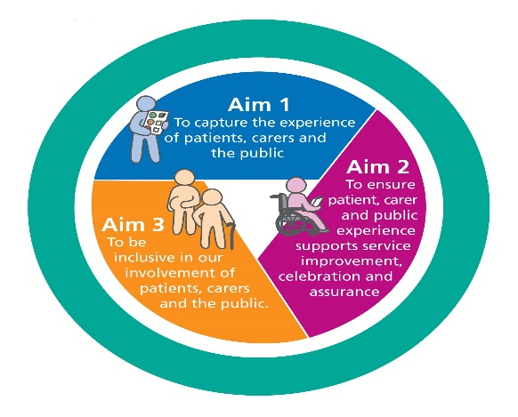
The 8 big themes are below with an explanation. We are asking people to read this and share their thoughts about them using a survey. The link to this survey is on the final page with a QR code which can also be used. We are also inviting people who have direct experience of using our cancer services to take part in an online workshop. There is a link to this flyer on the final page also.
Please read about the themes below and complete our survey. We greatly appreciate your support.

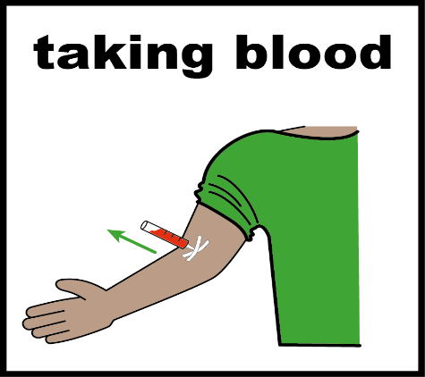 | 1: Reduce elective backlogs and achieve national standards.  This is about finding out if people have or have not got cancer much faster and earlier than in the past and telling them the results with them as quickly as possible. It is also about reducing the number of people on waiting lists, who are waiting for treatment.
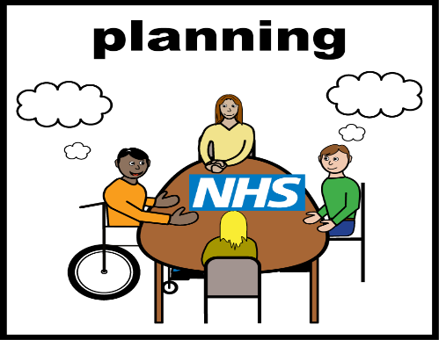 | 2: Effective forecasting for sustainable services.  There is increasing need for our cancer services. This theme is about understanding how we can improve our planning for the future and understand where our resources are most needed. This includes working out whether we have enough doctors to treat the predicted number of cancer cases in 2030.
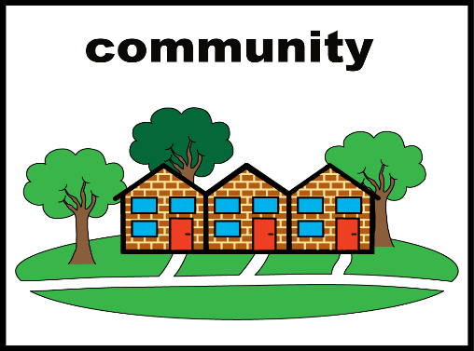 | 3: New care models to improve utilisation of the Trusts estate and resources.  The Trust will create new ways of working so patients can be diagnosed faster and treated closer to home when appropriate. This might include virtual clinics, one stop clinics or diagnostic hubs in the community.
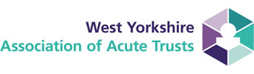 | 4: Collaboration with system partners to maximise our collective resources.  The needs of cancer patients are changing across West Yorkshire. Hospitals across the region will work together to share learning, resources and how they work. One example is making sure that G. Ps across the region can spot signs of lung cancer early or working more with pharmacists so that a patient’s cancer medication is closely managed. This is called a Pharmacy led clinic.
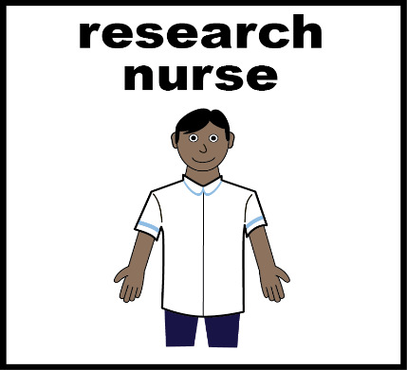 | 5: Translate research and innovation into better patient outcomes.  Research and technology play a huge part in delivering the best cancer care and treatment. The hospital will work more closely with people involved in research, including universities and industry, to adopt some of the newest developments. This includes both new treatments for cancer, and new models such as robots for surgery.
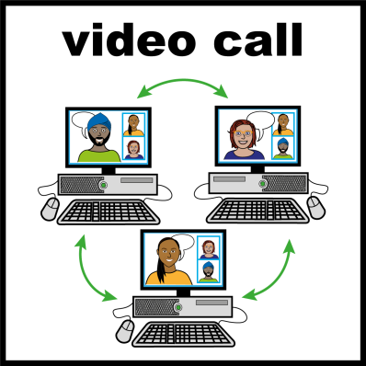 | 6: Use digital technologies to improve efficiency and service delivery.  Digital technologies will be used to make sure services are working as efficiently as possible and help to reduce patient travel where preferred. This will help to have the right staff in the right place and that money is spent in the best way possible. Examples include the use of Microsoft Teams for triaging patients or using virtual clinics for follow-up appointments.
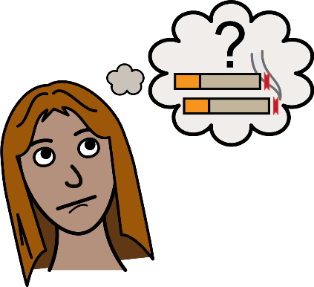 | 7: Reduce health inequalities in access to and outcomes from cancer services.  Some communities find it difficult to access cancer services and experience poorer outcomes than the rest of society. Reasons include where they live or how much money families have. One way to tackle this is by helping people to stop smoking and having staff in the community who can help diagnose cancers earlier.
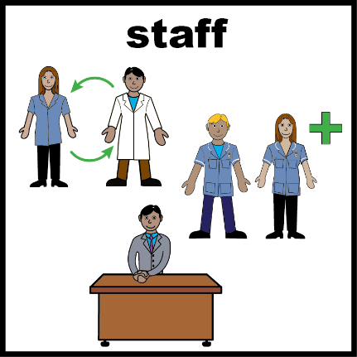 | 8: Increase the workforce and skills mix of staff  More people are getting cancer. This means that more staff will be needed to provide care and treatment for them. We will also provide education and training opportunities to help staff develop and learn new ways of working to help treat cancer.

To complete our short survey please use the link below. Your feedback will help the Trust decide the final themes for the cancer strategy and be used at our online workshop for further discussion.

http://ratenhs.uk/q1jr0y (this link will take you to the survey)
This QR code can also be used to take you to the survey. Simply open the camera function on your mobile phone and hover this over the QR code. The survey will appear after a short period of time.

