INFERTILITY OR VASECTOMY REVERSAL ANALYSIS

INFORMATION FOR PATIENTS

You and your partner may be having difficulty in conceiving a baby. In the laboratory your semen sample will undergo microscopic examination, which will help indicate whether a male factor is involved. We assess motility, sperm concentration and total count, and morphological appearance as well as other parameters that are helpful in providing important diagnostic information. This knowledge will help your doctor to plan any future treatment.

OR

You have had a vasectomy reversal. Your sample will undergo microscopic examination to verify whether you are producing potentially fertile sperm.

ARRANGING YOUR APPOINTMENT

Please contact the department on 0113 2067110 to arrange your appointment. Appointments are available 8:30 to 14:30 Monday to Friday (excluding Bank Holidays)

Please remember to abstain from any sexual activity that results in ejaculation (intercourse or masturbation) for at least 2 days before your appointment, but no longer than 7 days.

Samples can be produced at home or at the hospital. Please indicate which you prefer when booking your appointment.

SAMPLE PRODUCTION INSTRUCTIONS (on day of appointment)

A: What to do if arranged to produce your sample at Seacroft hospital

Instructions
- Please arrive for your appointment at the exact time at:
Histopathology Department Andrology unit,
Seacroft Hospital,
Leeds,
LS14 6UH (See attached map)

- When you arrive in the department on the day of your appointment, please ring the bell at the entrance to the department and await further instructions from a member of staff.
- At the time of your appointment you will be taken to a private room where a member of staff will leave you to produce your sample.
- Once in your private room please wash your hands and genitals.
- Produce your sample by masturbation.
- Collect the entire sample directly into the container provided by us. Do not use a sheath/condom for collection, or use any lubricant while masturbating, as they are harmful to sperm.
- On the provided request form complete your personal details ensuring the name of the requesting GP/consultant and their surgery/department details are also stated. Also record the date, time of sample production, length of abstinence (time without sexual activity resulting in ejaculation) and completeness of sample in the appropriate section
- After producing your sample, a member of staff will check your request form, take your sample from you and answer any questions you may have.
- Your appointment on that day is then over and you may go home.

B: What to do if you arranged to produce your sample at home (and will deliver the sample to Seacroft Hospital, Leeds)

Instructions

- You will need to produce your sample in a pot that has been specially tested to be non-toxic to sperm. This will be posted to you after arranging your appointment.

- Please wash your hands and genitals.
- Produce your sample by masturbation ONLY. Do not produce your sample by Coitus interruptus (withdrawal method) as this can affect your results. Collect the entire sample directly into the container provided. Do not use a sheath/condom for collection, or use any lubricant while masturbating, as they are harmful to sperm. If you have trouble producing your sample, please get in touch with the department for advice.
- On the provided request form, complete your personal details ensuring the name of the referring Doctor and their surgery/ clinic details are also stated. Also record the date, time of sample production, length of abstinence (time without sexual activity resulting in ejaculation) and completeness of sample in the appropriate section.
- Write your full name, date of birth, date and time you produced your sample and the referring Doctor/clinic on the container.
- Please ensure you deliver your sample to the department within 30 mins of production. We ask this because need to examine the sperm as soon as possible to achieve an accurate result.
- Please keep your sample as close to body temperature as possible during transportation - tucked into the waistband of your trousers is ideal.
- Please arrive for your appointment at the exact time area at:

Histopathology Andrology Unit
Seacroft Hospital
Leeds
LS14 6UH
(See attached map)

- When you arrive at the department on the day of your appointment, please ring the bell at the entrance and await further instruction from a member of staff.
- The member of staff will take you to a reception area where he or she will check your request form, take your sample from you and answer any questions you may have.

- Your appointment with the department on that day is then over.

RESULTS / FURTHER INFORMATION

Your results will be sent to your GP or Consultant in 10 working days from your appointment.

If you are requested by your GP/Consultant to provide a second sample, call 0113 2067110 to arrange another appointment. Your second appointment must be at least 14 days after your first appointment.

If you have any concerns regarding your sample or results, please contact your GP or Consultant.

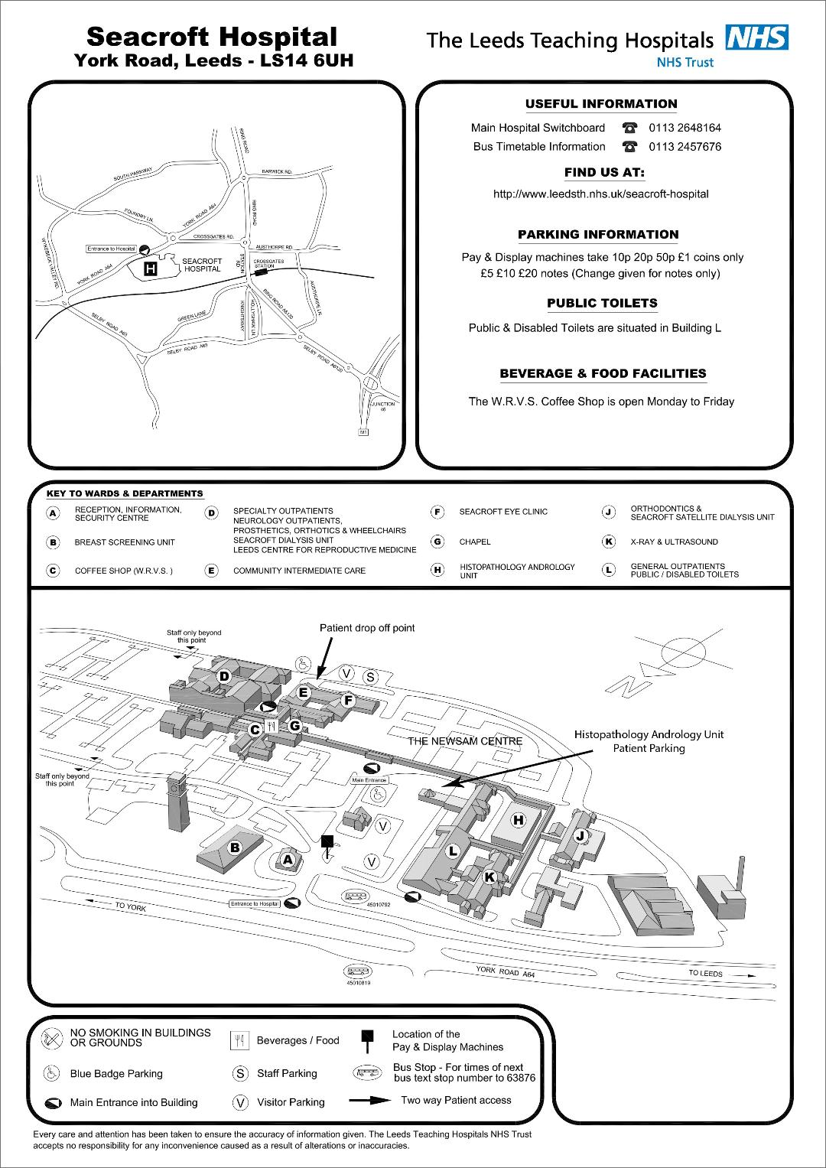

Visit our website for Seacroft Hospital maps, opening times and further information.

