SEMEN ANALYSIS INFORMATION FOR CLINICIANS

Introduction
This user information provides policies, procedures and repertoire of the Histopathology Andrology Unit, Seacroft Hospital, Leeds. The department is manned by fully trained staff, who work in accordance with WHO 2010 Examination and processing of human tissue, the ABA 2012 Laboratory Andrology Guidelines for Good Practice and Hancock et al 2016 Laboratory Guidelines for Post Vasectomy Semen Analysis :Association of Biomedical Andrologists, British Andrology Society and British Association of Urological Surgeons. J. Clin. Pathol. 2016; 0: 1-6

Contact Details
The postal address for the Andrology Unit is:
Histopathology Andrology Unit
Seacroft Hospital
York Road
Leeds
LS14 6UH
Tel: 0113 2063127 (Laboratory)
0113 2067110 (Appointment line)
The Andrology Unit is part of the Cellular Pathology Department, which is based at St James University Hospital, Leeds. The Leads for the unit comprise:
The Lead Scientist for the Andrology Unit is Mrs Janine L. Smith MSc FIBMS.
Clinical Interpretation can be given by Ms Karen Thompson (Clinical Embryologist) - contact the department on 0113 2063127

Location
See attached map
Services
The following analyses are performed by the Andrology Unit:
1. Diagnostic semen analysis (Infertility testing)
2. Post vasectomy semen analysis (PVSA)
3. Reversal of vasectomy semen analysis

Opening times
- The Andrology Unit is open Monday to Friday 08:45 - 17:00 (excluding Bank Holidays).
- The patient MUST arrange an appointment for delivery of their sample. The Andrology appointment telephone number is 0113 2067110.
- Infertilty/reversal analysis - AT PRESENT can be produced on-site and off-site. If samples are produced off-site, then the patient must deliver it to the department within 30 mins of production at the time of the prearranged appointment.
- Post vasectomy sample - initial samples after the vasectomy procedure - AT PRESENT can be produced on-site and off-site and brought to the department within 2 hours of production at the time of the pre-arranged appointment. If sperm are seen in this initial sample, then guidelines state subsequent samples must be examined within 1 hour of production in order confirm motility status of any sperm present. Consequently, patients will need to deliver subsequent samples within 30 mins of production to the department to allow time for receipt of sample.

How to request a semen analysis
1. Give the patient the following forms (these can be found on Leeds Health Pathways - links below)
a. Semenology request form (please complete the referring Doctor and surgery/clinic address for the patient)
http://nww.lhp.leedsth.nhs.uk/referral_forms/187.pdf
b. Depending on the analysis required please give the patient either:
i. Infertility or Vasectomy reversal information for patients form
http://nww.lhp.leedsth.nhs.uk/referral_info/187reversal.pdf
ii. Post vasectomy semen analysis information for patients form
http://nww.lhp.leedsth.nhs.uk/referral_info/187PostVas.pdf
2. Explain to the patient to arrange an appointment with the Andrology unit on 0113 2067110 as explained on the patient information sheet.

Instructions for the production of semen samples
Instructions for the production of semen samples can be found in the aforementioned patient information leaflets. Patients should be advised to follow the instructions as shown in the relevant leaflet, according to the test required, in order to optimise the semen sample they produce.
The patient must:
- Wait at least 12 weeks and 20 ejaculations before producing their first sample for Post Vasectomy Semen Analysis.
- Any sexual activity that results in ejaculation (intercourse or masturbation) for at least 2 days before your appointment, but no longer than 7 days.
- Only use the pot provided by the department to collect their sample. Patients will be sent a pot by post from the Andrology Unit.
- Deliver samples within 30 mins of production (iinitial (first) samples for Post Vasectomy Semen Analysis can be delivered to the department within 2 hours of production)
- Produce their sample by masturbation only, and not by 'withdrawing' after intercourse.
- Not use a condom to collect their sample as condoms can adversely affect sperm quality.
- Not use lubricants when producing their sample.
- Attempt to collect the entire sample in the pot and advise a member of staff if any of the sample is not collected.
N.B. Incomplete PVSA samples will not be accepted.

Instructions for the transportation of semen samples
- Please advise patients not to use a condom or lubricants when collecting their sample. These can adversely affect the quality of the sperm.
- Please ask patients not to expose the sample to extremes of temperature. Carrying it inside a pocket close to the body would be ideal.
- Samples via post or courier will not be accepted.

Routine tests provided
1. Diagnostic Semen Analysis and Reversal of Vasectomy Semen Analysis
SEMINAL PARAMETER | COMMENTS
Ejaculate volume | The of volume of the ejaculate measured in millilitres (ml)
Viscosity | A qualitative assessment of how viscous a sample is. Measured  as low, medium or high
Appearance | A qualitative assessment of the visual appearance of the  ejaculate. Eg Normal, opaque etc
Agglutination | A qualitative assessment of the amount of sperm 'sticking' together. Reported as none, <10% or >10%
Sperm motility | The motility of at least 400 sperm is assessed (at 37°C) and expressed as a percentage, showing progressive, non- progressive or immotile.
Sperm concentration | Expressed as millions of sperm per ml of ejaculate (millions/ml)
Total sperm number/ejaculate | Expressed as millions of sperm per ejaculate
Sperm morphology | The morphological appearance of at least 400 sperm are  assessed and expressed as a percentage of sperm with normal  morphology.
2. Post Vasectomy Semen Analysis
RESULT | COMMENTS
Absent | No sperm were seen in the entire sample
Scanty | 1 - 5 sperm were seen in 10μl portion of the sample
Moderate | 5 - 50 sperm were seen in 10μl portion of the sample
Many | >50 sperm were seen in 10μl portion of sample
Number of sperm were seen in the centrifuged sample | Number of sperm seen in the entire sample (prepared from a pellet produced from the centrifugation of the entire pellet)

Reporting of results
All semen analysis report forms are generated by the Cellular Pathology Sunquest COPATH™ System and sent to the referring clinician by post.
Some (but not all, at present) hospital departments and surgeries also have the ability to generate reports electronically.
Regarding PVSA samples if the guidelines given by us (as recommended by the ABA) are not adhered then a report will be issued stating that examination of the sample has occurred outside the recommended parameters and consequently giving clearance to the patient is not advised.

Turnaround times
Return of results to the referring clinician should be expected within 14 days of receipt of sample.

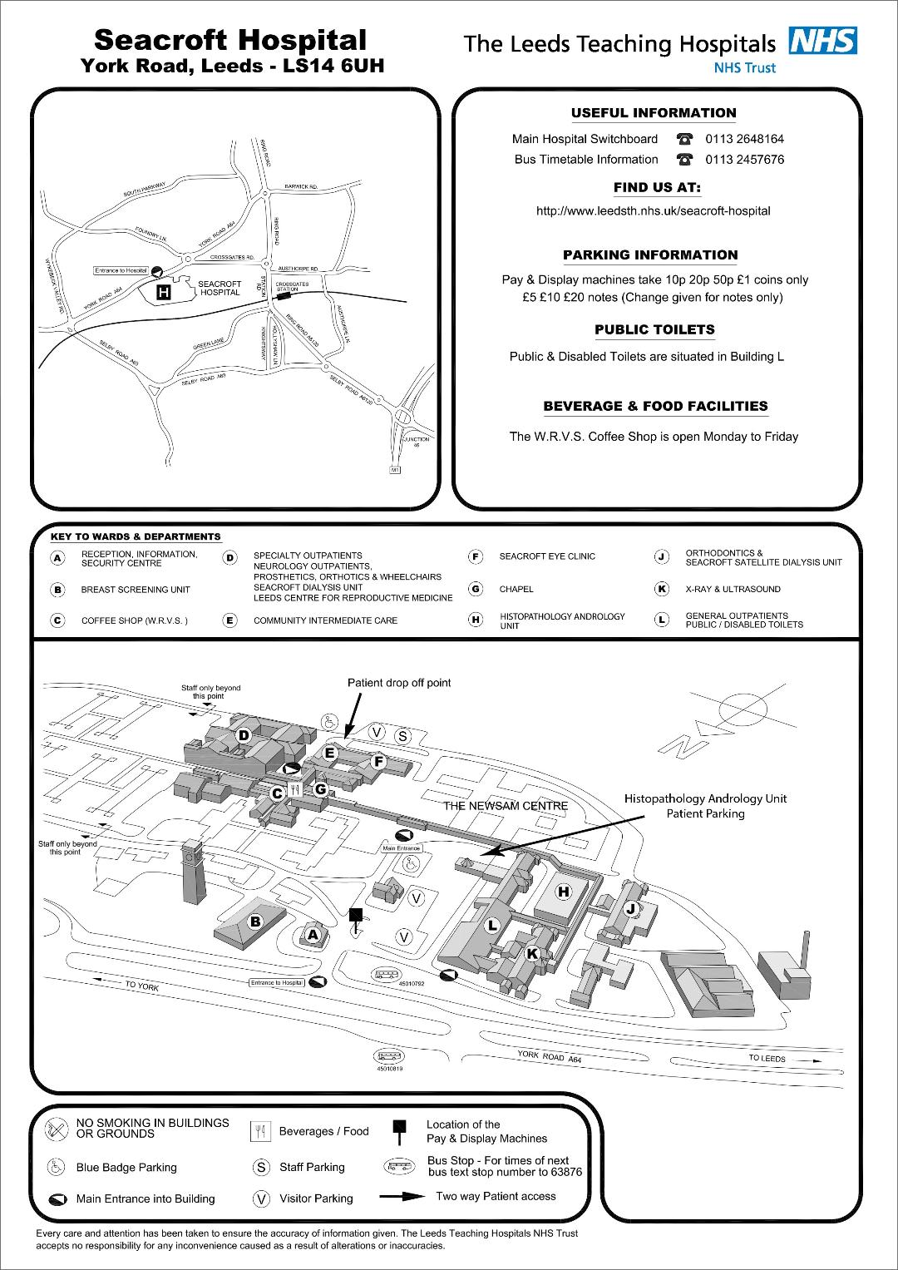

Visit our website for Seacroft Hospital maps, opening times and further information.

