

LTHT Workforce EDI Action Plan
April 2024-Oct 2025
At LTHT, we have committed that “We are inclusive and champion diversity” , as one of our People Priorities.
We are progressing our ambition to be fully inclusive using the NHSE EDI Improvement plan 6 high impact actions and continuing to embed our ‘Three Strand Approach’ to: De bias our processes, Embed a culture of Conscious Inclusion and Take positive action.
Our workforce information is measured and reported nationally each year through the Workforce Race Equality Standard (WRES), Workforce Disability Equality Standard (WDES), the Gender Pay Gap Report (GPG) and the NHS Staff Survey (NHSSS), as well as monitored locally across the city of Leeds and wider Yorkshire Region. This year we are also reporting on our Ethnicity Pay Gap (EPG). We are required to ensure this data is visible and publish this on the Trusts Internet by 31st October 2024. We are also required to publicise the actions we are taking to address what both this data and are staff are telling us. This document outlines the actions LTHT will take in 2024/2025 to build on successes and address areas needing improvement. These actions will respond to both the metrics we can see in our reported data, but also areas less easily measured based on intelligence shared through our Equality Staff Networks.
All actions are underpinned by the Equality Act 2010 and designed in collaboration with our five LTHT Equality Staff Networks (the Disabled Staff Network (DSN), Black, Minority Ethnic Staff Network (BME), Empower Leeds Women Network (ELW), Lesbian, Gay, Bisexual & Trans+ Network (LGBT+) and Faith & Belief Network). Actions are then approved by the Trust Equality, Diversity & Inclusion (EDI) Strategic Group, which reports to the Trust Board via the LTHT Workforce Committee.
This plan embeds both our established “3 strand approach” and NHS Englands EDI Improvement Plan High Impact Actions, which were first published in June 2023. NHS equality, diversity, and inclusion improvement plan (england.nhs.uk)
Our latest reported data shows that whilst LTHT has made improvements in some areas of our workforce equality measures, there are still many improvements to be made. This action plan identifies the opportunities where LTHT can focus measures to make impact.

2024/2025 LTHT Key Equality Priorities;
Over the next year, we want to continue sharing and developing measures which build the LTHT culture of Conscious Inclusion; where staff feel they belong, are empowered to use their voice, share their experiences and feel safe to raise concerns and challenge poor workplace behaviours in the knowledge they will be listened to. To enable this we will prioritise the actions below:
- Embed the Inclusive Recruitment Practices, underpinned by the LTHT Recruitment and Selection Policy and Inclusive Recruitment Training packages.
- Progress the use of Equality Impact Assessments as ‘Business as Usual’ practice when individuals, teams and Trust Board are developing and reviewing plans, policies and procedures, introducing measures and making key decisions.
- Design standard metrics which enable the health inequalities of our workforce to be articulated and where necessary actions to address implemented.
- Improve the quality of our workforce data captured through ESR (electronic staff record) across all protected characteristics.
- Build on our allyship model, so all staff at LTHT feel empowered to call out behaviours which are not inclusive nor reflect the Leeds Way and are staff are equipped and confident to take real time action to address.
- Build the capability of our managers to confidently discuss and address areas supporting conscious inclusion with their teams.
- Strengthen the visibility of both the role our Equality Staff Networks and EDI Champions have, and the contribution both make to advancing the Trusts ambition to be fully inclusive.
- Work with colleagues across the city and the region to establish the West Yorkshire Equality Strategy and collaborate in the sharing of data and good practice initatives.

Over arching Commitment; Committed Action April 2024 - Oct 2025 Success Measure October 2025
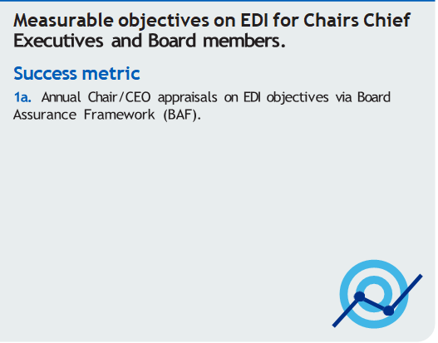
- Each Board member has an EDI objective within their annual appraisal which they are held accountable for
- Our Executive Sponsors are actively engaged with their LTHT Equality Staff Network and together plan activity to address challenges in EDI metrics and network intelligence to address improvements
- Our LTHT Board are represented and involved with any of our Positive Action programmes
- Quarterly joint Equality Staff Network Chairs meetings are in place, each chaired by a rotating Executive to support informing the wider Board with actions and challenges faced by members.
- Our LTHT EDI data and action plan is shared and agreed with the Trust Chair and Executives and objectives to support its delivery are put in place.
- Executive Team Sponsorship continues for each of our 5 Equality Staff Networks and their sponsorship supports the shaping and delivery of objectives to meet the actions within the EDI action plan.
- Executive Team invited to attend, participate in and take action in support of our positive action programmes.

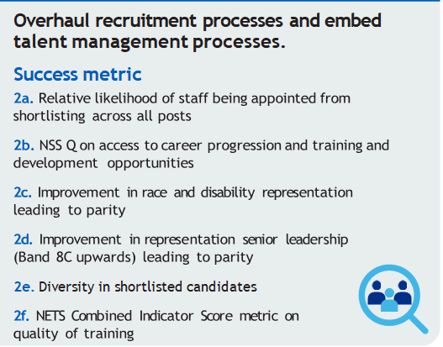
- Trust Board to approve the publication of the LTHT Recruitment & Selection Policy which will be rolled out from June 2024.
Their approval and support Includes;
- Local compulsory Training compliance for anyone involved in the recruitment and selection process
- The removal of access to the NHS Jobs platform for anyone who has not completed the local compulsory Training.
- Trust Board are to have sight of monitoring metrics to identify the impact of the introduction of the policy

- LTHT Recruitment & Selection Policy adhered to
- Exception Requests are only considered under review of the HR Director and decisions relating to any exception to the policy rules are monitored
- Improvement in both the WDES & WRES metrics regarding interview to appointment
- Recruitment and selection data at each stage of the process from application through to appointment across all protected characteristics
- Continued Improvement in NHSSS responses regarding belief in fair career opportunities.
- Improvement in Trust ESR* data measures re representation of BME staff, LGBT+ staff and disabled staff across all roles
- Improvement in representation in 8c and above roles

Over arching Commitment; Committed Action April 2024 - Oct 2025 Success Measure October 2025
- Capture and publish the LTHT Gender Pay Gap (GPG) and the LTHT Ethnicity Pay Gap (EPG) data and establish a plan to define disability pay gap measures to be in place for 31st March 2025.
- Continue to Promote the LTHT Flexible Working from day 1, embedding in all recruitment and promotion activity
- Continue to direct targeted Positive Action programmes to support personal and professional development and optimise diversity in senior leadership teams
- Collaborate and support our equality staff networks to drive activity to aid understanding of data and design approaches to address challenges, including promoting a culture to apply

- Improvement in both GPG and EPG data
- Baseline report in place for disability pay gap (by Mar’25)
- Trust Guidance available for managers on expectations to be in place to facilitate staff returning to work whilst Breastfeeding
- Qualitative review of feedback from medical workforce to establish barriers on female progression and pay award with actions identified to take forward
- Qualitative review of feedback from BME staff on the EPG and plan to act
- Qualitative review of feedback from LGBT+ and Disabled Staff to establish unknown and unaddressed barriers impacting pay awards / promotion

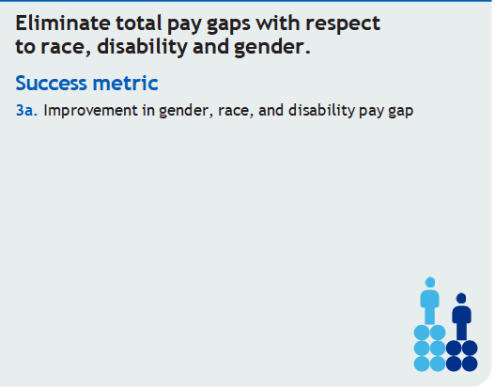

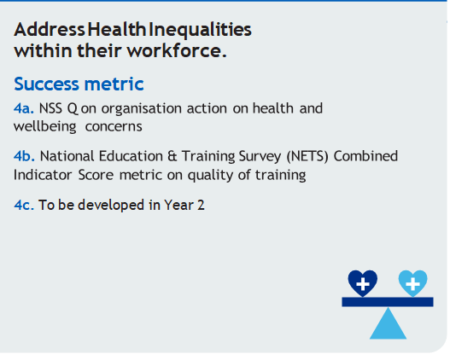
- Monitoring the LLETS, address areas identified where learners report less favourably in their experiences
- NSS results show improvement in staff reporting their line manager takes an interest in their health & wellbeing
- Baseline report in place and actions and measures embedded for reducing health inequalities within our workforce
- Training offer on health inequalities developed and accessed by staff, including those at risk

- Introduce the LLETS, the Leeds Learning, Education and Training Score, a universal measure to monitor the experiences of all learners at LTHT
- Embed Health Inequalities into Health & Wellbeing Conversations within good people management practices
- Develop a baseline report on health inequalities within our workforce and a comprehensive approach to tackle with reference to actions identified through Leeds One Workforce Strategy, Leeds Health Inequalities Oversight Group and LTHT Public Health and Health Inequalities Strategy and Group
- Contribute to the development of a workforce training offer on health inequalities being developed by the Leeds Health and Care Academy.

**Anchor Institute; large organisations whose long-term sustainability is tied to the wellbeing of the populations they serve.
^CORE20PLUS5; a national NHS England approach to support the reduction of health inequalities at both national and system level
Over arching Commitment; Committed Action April 2024 - Oct 2025 Success Measure October 2025
- LTHT Recruitment & Selection Policy in use and policy being adhered to.
- Method of identifying individuals joining the Trust from overseas (outside of a cohort process) is in place and is monitored for impact
- Build on and improve managers guides to support the induction of staff from overseas following evaluation and feedback from new starters
- Improvement in NHSSS results in terms of belonging
- Evidence of parity of experiences for learners who join us from overseas with those from UK.
- LTHT Recruitment & Selection Policy introduced with specific guidance associated with international recruitment
- Create a multidisciplinary working group who regularly meet to review international recruits feedback, identify areas to improve and seek to expand access where successful measures have already been introduced
- Embed a method of identifying overseas recruits who are joining the Trust outside of a cohort process, so individuals receive access to bespoke orientation support where needed.
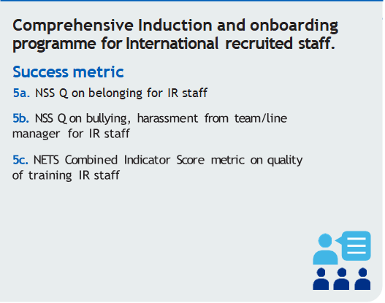
- Improvement in NHSSS and NETS reporting regarding bullying & harassment
- Evidence that Toolkits provided are being accessed and used within teams with evaluated outcomes
- A universal measure in place to monitor the experiences of learners at LTHT and identify areas of disparity and link to any minorities and groups of staff, including students/learners, bank workers, international recruited and subcontracted staff.
- Community of Practice in place to support staff who have agreed to take on the champion role modelling escalation best practice and evidencing where their listening has had positive impact.
- 10,000 staff to have accessed the stories LTHT staff have shared in the Amplifying Voices Mending Divides book
- Inclusive Conversations at work are evidenced as happening and staff report they are having a positive impact
- Resources in place to support managers create inclusive environments, eg practical guides to support Trans Awareness and Uniform requirements to meet Faith & Belief needs
- Actions identified in the 2023/24 Muslim Staff Survey have been implemented.

- Continue to promote opportunities for staff to navigate good people management fundamentals, where behaviours are addressed and challenged in line with the Leeds Way Values including:
- Management Fundamentals Toolkit
- Kindness and Civility Toolkit
- Report for Support Resources
- Promote all the routes for concerns being raised (Freedom To Speak Up, Dignity at Work, EDI Champions etc) and provide assurance that information is captured, irrespective of route. Build the capacity of staff supporting speaking up routes through on going engagement and supporting developmental needs. To ensure to include the experience of students/learners, bank workers, international recruited and subcontracted staff.
- Collaborate with our Equality staff networks to identify where staff feel their experiences are impacted by their declared protected characteristic

- Embed the art of Inclusive Conversations within Team development and manager training.

