Title: i-STAT Alinity Analyser User Guide
Site/Area of application | Point of Care - Produced specifically for Ward Users
QPulse Number | POCT-SOP-15 Version 1.3
Superseded documents | POCT-SOP-15 Version 1.2
Implementation date of this version | 31st August 2021
Author(s) | Hannah Webley
Reason for change
Updated to reflect POCT service hours
Impact on training needs and requirements for competency assessment
This is a new procedure Acknowledgment of notification is taken to be your confirmation that you will ensure you are familiar with and implement the processes described. A process of training and assessment of competency is required.

Keywords for search
Point of Care, i-STAT, creatinine

This document is controlled using the Pathology QPulse software. Controlled printed copies can be identified by the authorisation signature present in the space below. Upon request further authorised copies can be obtained through the department’s quality system. Uncontrolled copies may be printed for an individual’s use but should not be used after 1 week from the date of printing.

Signature

Contact Details | Office hours: Mon-Sat 08:30-17:00  Call: 0113 39 22338 or 0113 20 64791 Email: leedsth-tr.pointofcare@nhs.net
Medico-Legal | It is important to not share passwords and always use the correct patient ID  - It is a legal requirement and trust policy for individual access not to be shared.  - Creates an Information Governance audit trail  - Enables test results to be recalled for specific users and patients  - Protects staff and patients from device misuse  Training updates are required every TWO years and untrained staff must NOT use the meter.  Each location should have a Key Trainer to cascade training to other staff members. Key trainers must receive a training update from POCT every 2 years.  Patient ID must be entered each time a sample is analysed. Acceptable forms of ID are:  - PAS number - NHS Number - A&E number
Analyser overview (Hardware) | 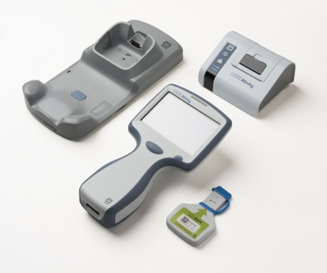  Electronic Simulator  Printer  Docking Station  On/Off Button  Cartridge Port  Scan Button  The battery is rechargeable and will automatically charge when the analyser is docked. When the meter is docked correctly, the lightening symbol is visible on the battery icon in the top right hand corner of the screen.  Creatinine Cartridges- Box of 25- expire after 14 days if stored at room temperature (date of opening should be noted on the packet) or until the expiry date if refrigerated (2-8°C).  A single cartridge should be at room temperature for 5 minutes before use or a whole box for 1 hour.  Do not open the cartridge pouch before you are ready to use it. A filled cartridge should be inserted into the analyser immediately.  i-STAT Controls (QC)- Box of 10- must be refrigerated (2-8°C). Unopened ampules are stable at room temperature for 5 days, or until the expiry date if refrigerated (2-8°C).  Cartridges and QC solution should be ordered directly from Abbott. See the ward handbook for further details.
Analyser overview (Screen) | - Patient testing can be accessed using the main screen. All others functions can be found in the ‘More Options’ section.
Calibration | The Electronic Simulator test MUST be analysed every 24 hours to ensure analyser is working correctly. The analyser will not allow patient testing until this has been performed.  - Turn on the analyser  - Press More Options > Quality Options > Perform Electronic Simulator Test  - Scan the barcode on your Trust ID badge  - Scan the barcode on the Simulator cartridge  - Enter the Simulator into the sample port on the bottom of the analyser  - The analyser will lock the Simulator in place until testing is complete. DO NOT remove the Simulator  - Once the result is displayed, press Home and when prompted, remove the simulator  - Record the result in the i-STAT Alinity Ward Handbook. Results must be emailed to POCT on a weekly basis.  Should the Simulator fail the test, repeat the test. If it fails a second time, please contact POCT
Quality Control (QC) | QC (Quality Control)  - QC consists of 2 solutions, level 1 and 3.  - QC must be performed weekly. The analyser will lockout and patient testing cannot be performed until QC is analysed.  - QC must also be performed for a new lot number of cartridges and a new delivery of cartridges.  - Importance of QC- to check analyser performance and user technique  - QC ampules must be at room temperature for 30 minutes before use  - You must contact POCT when you receive a new lot number of QC in order to update the pass/fail ranges.  Technique  - Press More Options > Quality Options > Quality Control > Scheduled QC. The analyser will display the date and time that the QC is due and will not allow you to perform the weekly QC until this time.  - NOTE: If you are performing QC due to a new lot or delivery of cartridges, press More Options> Quality Options> Quality Control> Unscheduled QC.  - Scan the barcode on your Trust ID badge  - Scan the barcode on the vial of QC  - Scan the barcode on the cartridge pouch  - Shake the ampule of QC solution vigorously for 10 seconds. Snap the tip of the ampule off at the neck. QC testing must be performed within 10 minutes of opening the ampule.  - Using a blunt tip needle, immediately transfer the QC solution into a syringe. If air is trapped between the leading edge of the solution and the plunger, do not invert the syringe to expel it. If there are air bubbles throughout the sample or near the tip, discard the ampule and syringe.  - Remove the needle and discard the first two drops of QC.  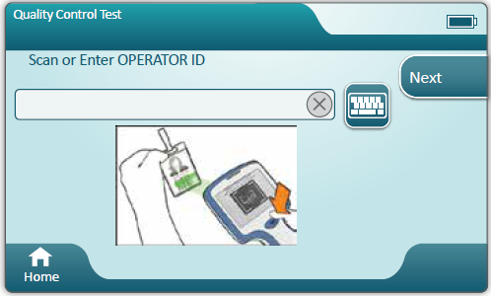  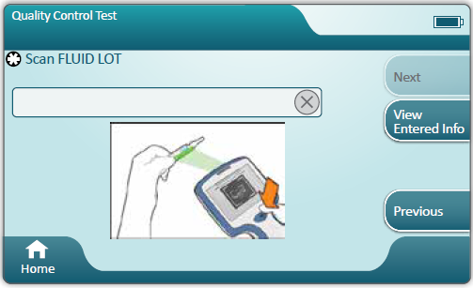  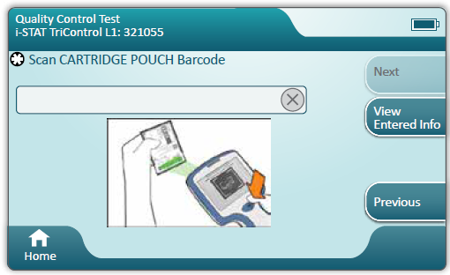  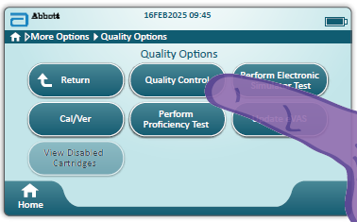  1  2  3  4  - Open the cartridge pouch. Only hold the cartridge by the bottom or the sides, NEVER by the middle as this may prematurely release the reagents. Insert the syringe into the cartridge and fill to the cartridge fill mark.  - Close the cartridge and immediately insert into the analyser.  - Keep the analyser flat until analysis is complete  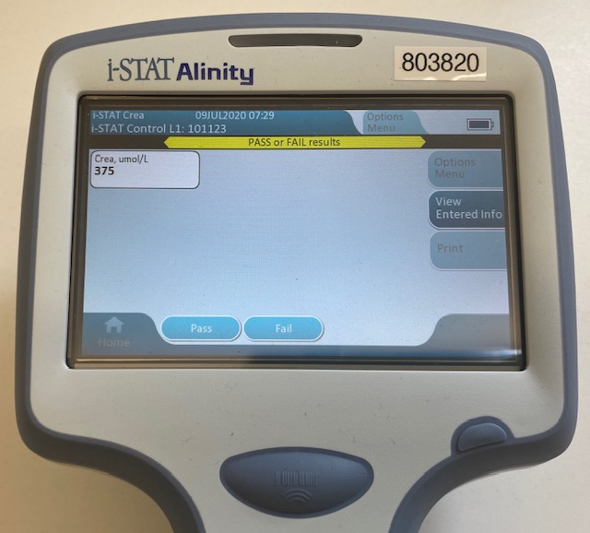  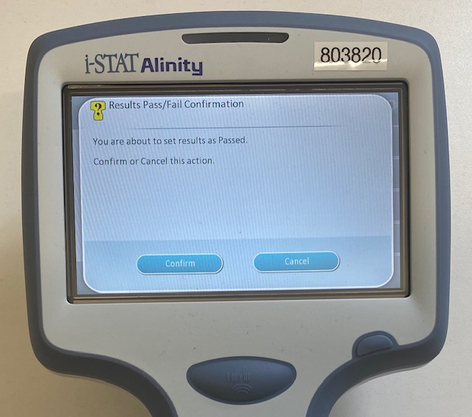  11  12  - The result will be displayed on screen. The pass ranges are stated in the ward handbook on the QC page. Check the result against this table to determine whether the QC has passed or failed.  - Select the relevant pass/fail button on the analyser screen then press confirm. The analyser will display the result with the correct pass/fail status.  - To run level 3, press Options Menu > Run a different fluid control solution. Follow the process above to perform analysis of level 3 QC.  - Record the result in the i-STAT Alinity Ward Handbook. The results must be added to the SharePoint Excel sheet (Radiology Creatinine IQC – Working Copy) OR emailed to POCT on a weekly basis.  Should a QC test fail  - Check the expiry date of the QC and the cartridges  - Check the QC and cartridges were brought to room temperature for the required time before use  - Repeat the QC test with a new vial of QC  - Contact POCT if the test fails again  EQA (External Quality Control)  EQA is organised by an external organiser, and the aim is to compare your department’s performance with your peers nationally.  The POCT team will distribute the EQA bi-monthly with an instruction sheet. Run the EQA sample as a patient sample. Use the barcode at the bottom of the sheet as the patient ID. Samples must be analysed in the time stated on the sheet. Please email the results to POCT after analysis.
Health and Safety | - Conform to Trust Infection Control policies at all times.  - Gloves should be worn when handling blood samples.  - Spillages must be dealt with in line with Departmental H&S policies.
Maintenance | - Keep analyser clean from blood/spillages. Analyser should be cleaned between patient testing by using:  - Haz-Tab solution  - Green clinell wipes  - Biohazard wipes  - Do not get liquid inside the analyser
Pre-Analytical | - Dilutional Errors- samples taken from drip arms can be diluted by the infusion itself. Clear all lines thoroughly and be aware of infusion sites.  - Syringes and capillaries MUST be heparinised to prevent clotting and to prevent erroneous results from being obtained.  - Samples must be free from air contamination. Expel any excess air from the syringe and use the cap to seal the sample until ready for testing. Capillaries must not have bubbles in the sample.  - Samples taken into a syringe/capillary must be thoroughly mixed. Mix the sample by rolling the syringe between the palms of your hands. Capillary samples may be mixed by carefully rolling between your fingers.
Sample Analysis | 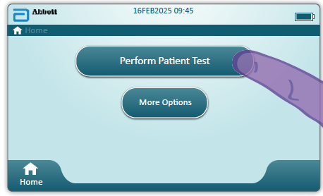  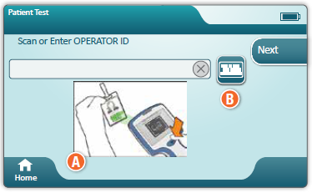  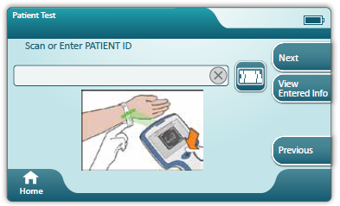  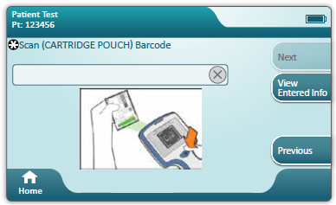  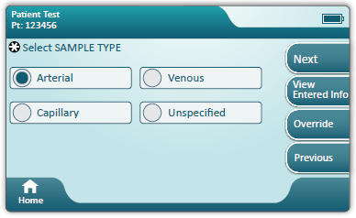  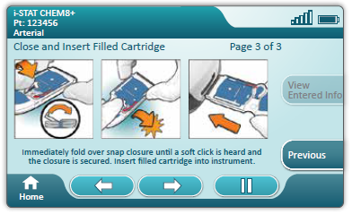  5  4  3  1  2  6  - Press Perform Patient Test  - Scan the barcode on your Trust ID badge  - Positively identify patient by confirming full name and DOB prior to testing. Scan Patient ID barcode or manually enter the patient ID  - Scan the barcode on the cartridge pouch  - Enter the patient’s age and select years, months, weeks or days then press Next  - Select the patient’s sex and press Next  - Select the sample type and press Next  - Open the cartridge pouch, taking care to only handle the cartridge at the edges and place the cartridge on a flat surface.  - Insert the syringe into the cartridge and fill to the cartridge fill mark. Close the cartridge and immediately insert into the analyser.  NOTE: Under or overfilling the sample path may produce erroneous results.  - The analyser will lock the cartridge in place until testing is complete. Do not try and remove the cartridge until the results have been shown on screen.  - Document result in the i-STAT Alinity Ward Handbook patient’s record. Take action in accordance with Trust guidelines.
Result Reporting | - Analytical range: Creatinine 18-1768 µmol/L  - Reference ranges will be displayed below the result  - and a yellow box indicates an out-of-range high result  - and a yellow box indicates an out-of-range low result  - A numeric result is preceded by a greater than (>) or less than (<) symbol, if the result is outside the analytical range  - *** indicates that the analyser is unable to determine a result  - <> indicates that the analyser cannot calculate the result  - A sample should also be sent to the lab for any patient if the result does not fit with the clinical picture or is outside the analytical range
Recall results | - Press More Options > Review Results.  - The analyser will display the options to view the last result, patient results, QC results or all results.  - Scan the barcode on your Trust ID badge.  - Select the result from the list and press View Selected.  - Analyser can store 500 results
Troubleshooting and Incident Reporting | - Any issues that cannot be resolved should be reported to Point of Care Testing as soon as possible.  - When reporting clinical incidents on DATIX, select the box for incidents involving Trust equipment and select ‘in-vitro Medical Devices’ from the drop-down list.

