Title: Siemens Blood Gas Analysers User Guide
Site/Area of application | Point of Care - Produced specifically for Ward Users
Index code | POCT-SOP-23 v1.4
Superseded documents | POCT-SOP-23 v1.3
Implementation date of this version | 23/10/2026
Author(s) | Hollie Wilkes, Hannah Webley, Rebecca Richards, Emma Baddams.
Reason for change
Addition of information to the Results section (p.10) stating that arterial reference ranges print out for both arterial and venous samples. Ensure wards aware to review and interpret according to local guidelines.

Impact on training needs and requirements for competency assessment
This is a new procedure Acknowledgment of notification is taken to be your confirmation that you will ensure you are familiar with and implement the processes described. A process of training and assessment of competency is required.

Keywords for search
Point of Care, Blood Gas, Siemens, RP500, RL1200, RapidPoint, RapidLab, BGA

This document is controlled using the Pathology QPulse software. Controlled printed copies can be identified by the authorisation signature present in the space below. Upon request further authorised copies can be obtained through the department’s quality system. Uncontrolled copies may be printed for an individual’s use but should not be used after 1 week from the date of printing.

Signature

Contact Details | Office hours: Mon-Sat 08:30-17:00  Call: 0113 39 22338 or 0113 20 64791 Email: leedsth-tr.pointofcare@nhs.net
Medico-Legal | It is important to not share passwords and always use the correct patient ID  - It is a legal requirement and Trust policy for individual access not to be shared.  - Creates an Information Governance audit trail  - Enables test results to be recalled for specific users and patients  - Protects staff and patients from device misuse  Training updates are required every TWO years and untrained staff must NOT use the analyser.  Patient ID must be entered each time a sample is analysed. Acceptable forms of ID are:  - PAS Number (preferable) - NHS number - A&E number  In case of an unknown patient, enter something as specific as possible e.g. ‘unknownmalecrash’ and contact POCT with the correct ID when known.
Analyser overview | 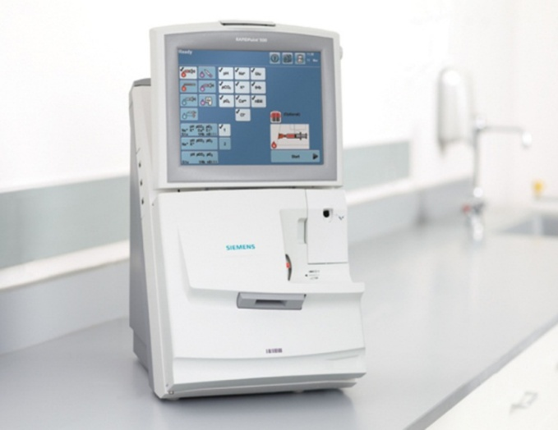  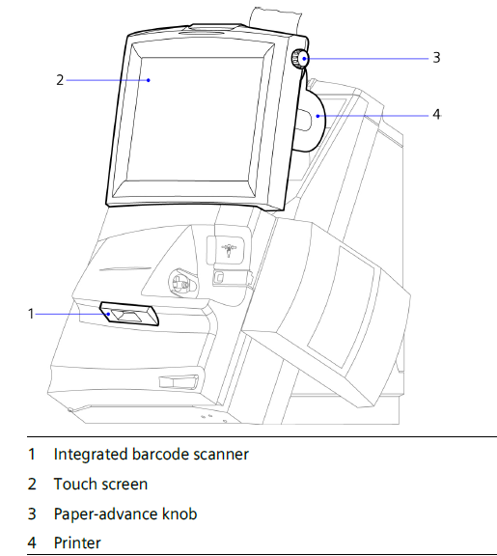  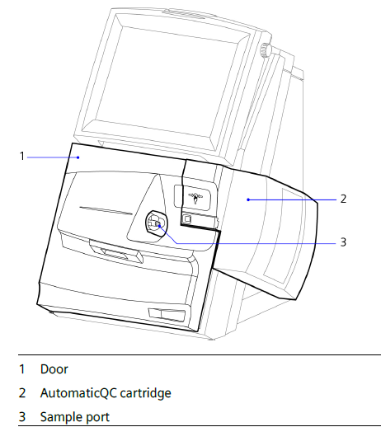  RAPIDPoint 500 and RAPIDPoint 500e Model  RAPIDLab 1200 Model (Delivery Suite ONLY)  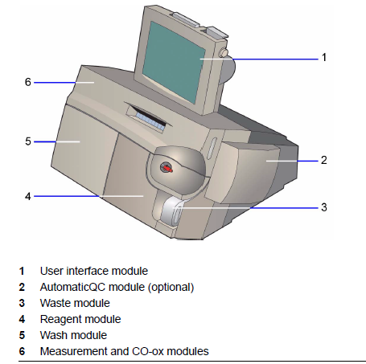  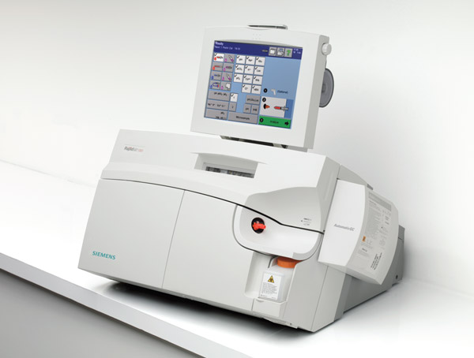  CONSUMABLES  - Blood syringes are delivered to low usage wards yearly and high usage wards on regular standing orders. If you need to place an additional order for blood gas syringes or capillary tubes, please email: leedsth-tr.procurementoffice-lgi@nhs.net  - Siemens RAPIDLyte Blood Gas Syringes Luer Lock (order code: 11561347 )  - Siemens RAPIDLyte Blood Gas Syringes with Safety Needle (order code: 11561349 )  - Siemens RAPIDLyte Multicap-S Plastic Capillaries (pot of 50 order code: 6440221, pot of 500 order code: 2043295)  - Siemens capillary caps (order code: 08685906)  - Sample ports (supplied by POCT Team)  - Printer paper rolls (supplied by POCT Team)  RAPIDLab 1200 ONLY  - Waste bottle (supplied by POCT)
Calibration | - 1 point every 30 mins (2:30 min), 2 point every 2nd hour (5:30 min) and full every 8th hour (8:00 min).  - The machine may calibrate up to 2 more times if a parameter fails.  - Calibrations will occur more frequently if the analyser detects an issue.      - DO NOT CANCEL CALIBRATIONS as parameters that have not passed a calibration will not be available.  - Failed parameters will be marked with a line or a cross. Samples can be analysed but results will not be produced for this parameter.
Quality Control (QC) | 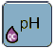    - 3 levels of Automatic QC, 2 levels analysed every 8 hours  - Failed QC is indicated by a QC droplet symbol in the parameter box.  - Samples can be analysed but results will not be produced for this parameter.  EQA (External Quality Control)  EQA is organised by an external organisation but the aim is to compare your department’s performance with your peers nationally. Samples are received monthly and will be analysed by the POCT Team. Any issues picked up by this will be acted on to ensure analysers are giving the correct results.
Health and Safety | - Samples must be capped as soon as possible after collection.  - Conform to Trust Infection Control policies at all times.  - Gloves should be worn when handling blood samples.  - Syringes and capillaries must be disposed of in a sharps bin.
Maintenance | Out of Hours Procedure  Analysers may experience unexpected errors outside of POCT hours. There are posters behind all analysers with information, including a flow chart of steps to follow.  Cartridge changes can be done out of hours by staff on wards if needed. This involves contacting the lab to request cartridges and the password of the day. A porter or someone from the wards will need to go to the Blood Sciences lab to collect these. There will also be some instructions to follow for replacing a cartridge along with the password – and the analysers will also display a video when the cartridge change is initiated.  The password of the day is monitored and should not be used for anything other than OOH cartridge replacements.  The poster also includes a phone number for Siemens, who can also offer advice out of hours.  Cleaning  Cleanliness of the blood gas machine is the responsibility of the user and the ward.  Analyser should be cleaned using either:  - Haz-Tab solution prepared within 24hrs or  - Biohazard wipes (order code H9730)  These are the only cleaning wipes approved by Siemens.  When cleaning a patient's skin at the sampling site, or any container (such as a kidney dish) that will be used to hold samples, ensure that the cleaned surface is allowed to dry completely before sample collection or use. This helps prevent residual cleaning ingredients from contaminating the sample and interfering with analyser sensor performance, which may affect test results.  ⚠️DO NOT USE green Clinell wipes or any other cleaning products on the blood gas analysers. Many cleaning products contain a component that damages the sodium sensor and produces incorrect patient results.  How to use the BioHazard wipes:  The wipes are dry as once activated the chlorine solution is only stable for 24 hours. They are 10,000ppm when activated by up to 30ml of blood when using for a blood spill. The wipes comply with DoH and HSE guidance for dealing with blood and blood-stained body fluid spills and meet standards BS EN16615:2015 and BS EN 13704.  Follow the instructions on the back of the packet:  General Environmental Disinfection:  - Remove wipe and re-seal pack  - Check the cold tap is running cold, and only wet the centre for 1 second  - Squeeze wipe over sink, bowl or bucket to remove excess water  For Blood and Blood-Stained Body Fluid Spillages  - Remove wipe and re-seal pack  - Absorb spill directly with the wipes  - Use another wipe – wetting the centre as per above instructions – to finally clean and disinfect the area  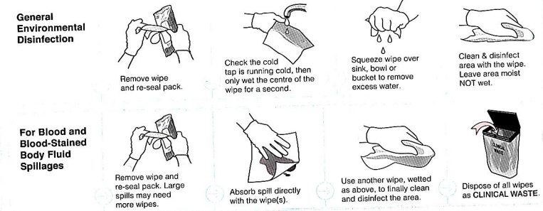  Common sodium sensor interfering substances that reach the sodium sensor from outside of the instrument are:  - Silver sulfadiazine  - Chlorhexidine  - Perhexiline Maleate  - Atomoxetine Hydrochloride  - Benzalkonium compounds  Printer paper  Needs to be replaced when the red stripe appears on printouts. Ensure that the paper is in the correct way by scratching it before inserting it into the feeder- a grey line will appear.  Spindles  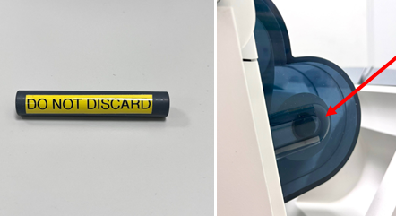  Spindles are the plastic tubes inside the centre of the paper roll, that sit on the side of the printer cover to hold the weight of the printer roll and prevent it from damaging the motor. They are labelled ‘do not discard’.  Please make sure that these are not thrown away with the old paper roll when it is replaced. The paper will pull on the motor, burning it out, and eventually the analyser will not be able to print results. This can only be repaired by a visit from a Siemens engineer, which may take a few days. There are costs to the trust for the new spindle and for the engineer visits to repair broken printer motors.  Screen  Don’t use pens or sharp objects on the touchscreen – fingers only.  RAPIDLab 1200 ONLY  New waste bottles are stored in the cupboard below the analyser.  - Remove the full waste bottle and secure the orange lid, dispose in a clinical waste bin.  - Insert a new waste bottle, ensuring the orange lid is located in the storage position and the waste container opening is inserted into the analyser first.  Every 2 weeks – POCT will run a deproteinising clean through the sensors. They will also check that the sensors are in good condition and replace them if needed. They will also check that the air filters are clean and free of dust build up. This can take around 1 hour.  Every 3 months – POCT will replace all sensors and the tubing. They will also replace the air filters. The clean is also done at the same time, so this can take up to 2 hours.
Pre-Analytical | Before analysing a sample, you must always:  - Avoid infusion sites and clear lines- Glucose, potassium and sodium can all be affected by the presence of a contaminating fluid. Clear all lines thoroughly and be aware of infusion sites.  - Expel Air- The presence of air in the syringe will affect the pO2 result. Cap the sample immediately after collection and expel all air through the filter cap.  - Mix- Samples must be collected into heparinised blood gas syringes or capillaries to prevent clotting. To ensure the heparin is distributed throughout the sample, invert sample at least 20 times and roll between your palms immediately. If the sample is not mixed prior to analysis, the red cells can settle and cause the Hb result to be greatly affected.  - Prevent Haemolysis - Small amounts of haemolysis can raise potassium results significantly. If blood is drawn under force or through a very small needle bore, the red blood cells may haemolyse (break) and release their contents. Small amounts of haemolysis can falsely elevate the potassium level significantly.  - Analyse within 10 minutes - all parameters are affected by delayed analysis due to cell metabolism; test within 10 mins of collection. A whole blood sample is living tissue; the white blood cells will continue to use O₂ and produce CO₂, glucose will be utilised and lactate will be created as a by-product.  Be aware that:  - Antimicrobial compounds - such as silver sulfadiazine and chlorhexidine, significantly affect sodium results and may affect subsequent sample analyses. These components can be contained in cleaning products.  - Patients on Vitamin B12 (Hydroxocobalamin) - may have lower than expected values for carboxyhemoglobin (fCOHb) and methemoglobin (fMetHb).
Sample Preparation | - Positively identify patient by confirming full name and DOB prior to sample collection.  - You must use a heparinised syringe or heparinised capillary to collect the sample.  - Label sample or kidney bowl with patient addressograph.  Syringes  - Syringes are pre-set to 1.5mL. Adjust fill line to the desired volume with minimum sample size of 1mL in a syringe.  - NOTE: When using the syringe with attached needle DO NOT push syringe to expel air prior to sample collection. This will expel the heparin and increase chances of clotting. When performing an arterial stab, place the syringe at a 45 degree angle and allow the syringe to auto-fill.  - Expel air into the filter cap, mix immediately after collection by inverting the syringe at least 20 times and roll between your palms and again prior to analysis.  Capillaries  - Minimum sample size ¾ of a 175µl capillary  - Capillary samples must be free of air bubbles and be one continuous line of blood.  - Capillary samples should be capped and rolled between the fingers. Mix the sample immediately after collection and again prior to analysis.  - Analyse the sample within 10 minutes of collection. DO NOT discard the sample until results have been printed and you are satisfied. You may re-analyse a sample as long as it is within 10 minutes of collection.
Sample Analysis | 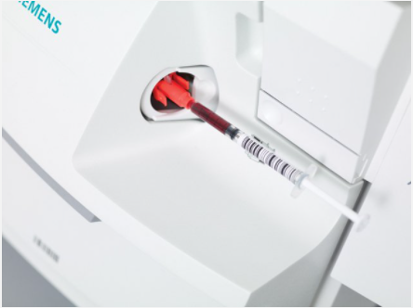  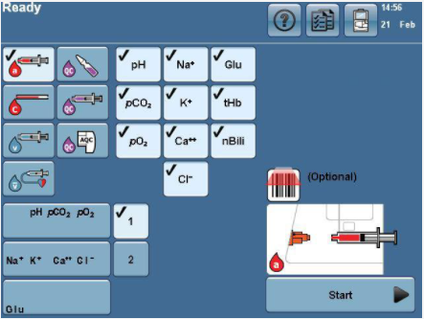  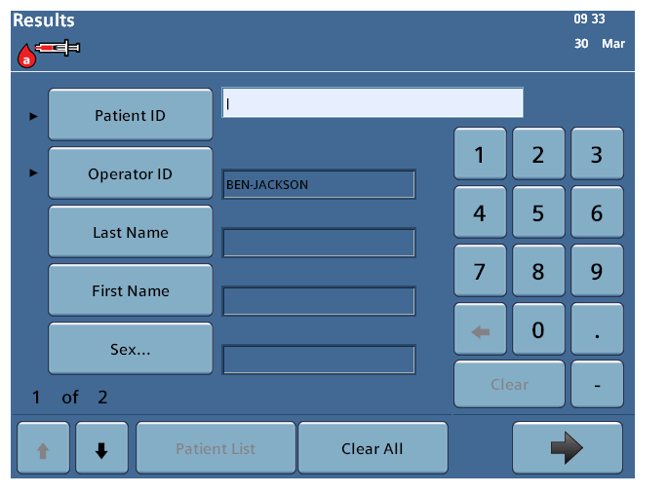  2  1  3  4  - Ensure the machine says ‘Ready’ in the top left corner, then login by scanning the barcode on your Trust ID badge.  - Select the relevant sample type  - Arterial  - Capillary  - Venous  - Mixed Venous  - Ensure sample is mixed well prior to analysis. If using a syringe, expel the first couple of drops into a sharps bin.  - Insert the sample into the sample port. For capillary samples, insert the opposite end to that used for collection.  - Select Start/Analyse.  - When prompted, remove the sample and press the arrow to continue. If using a syringe, expel the air and recap the sample until you receive the results.  - When prompted, scan patient ID barcode. Ensure the details are correct and press the arrow to continue.  - The analyser will display the results and print a copy automatically. Press the arrow button to logout.  - The analyser will run a wash cycle after every patient sample.  - Dispose of the sampling device in a clinical waste bin.
Analysing  Microsamples (RAPIDLab 1200 ONLY) | If you are analysing a sample on the RapidLab 1200 blood gas analyser and have less than 90µL of blood, you can still analyse your sample using the Microsample option.  You can perform a microsample either by selecting this from the main analysis screen before selecting the ‘analyse’ button or by allowing the analyser to prompt you that the sample volume is insufficient and allowing you the option to perform a microsample.  - Select the button for the patient sample type (arterial, venous, capillary, mixed venous) and then press Microsample.  - Insert the sample into the sample port and press Analyse.  *Note: If microsample was not selected before analyse, the analyser will detect an insufficient sample and prompt the user to select microsample or cancel. Select Microsample.  - When prompted remove the sample and press the arrow to Continue.  - To start the sample moving through the sample path, press Advance Sample.  - Watch the sample move into the sample path. For the first part of the analysis there must be continuous sample from the very left of the pO2 electrode to just beyond position 1, as shown below and press Stop sample once the sample reaches this point.  - Select Analyse. Wait whilst the system analyses pO2 and pCO2. After the system finishes the analysis it moves the sample to the remaining sensors.  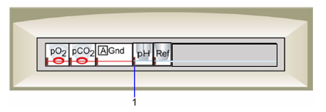  - Watch the sample move through the sample path and inspect the sample path for bubbles or gaps.  - Ensure that the trailing edge of the sample remains in contact with the Gnd sensor  - Ensure that the leading edge of the sample fills the Ref sensor, just beyond position 2.  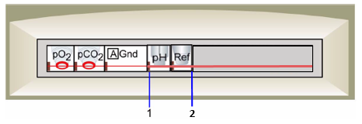  - If bubbles or gaps are present, select Cancel. If no bubbles or gaps are present select Analyse.  - When prompted, enter the patient ID (see above for acceptable ID).  - The machine will show the results when analysed and print a copy automatically. Press the arrow button to finish. The analyser will run a wash cycle after every patient sample.  - Dispose of the sampling device in a clinical waste bin.
Results | - Result printout must be checked for error flags detailed at base of printout. Flagged results may not be reliable.  - Please be aware, both Arterial and Venous samples will print out with ARTERIAL reference ranges. Venous gases should be reviewed and interpreted in accordance with local guidelines.  - Results should be reported according to ward/departmental procedures ensuring correct patient identification.  - In the case of an unexpected or abnormal result, the sample can be analysed again if still within 10 minutes of collection. Ensure the sample is mixed and contains no air bubbles, repeat the sample on the same analyser and a comparison analyser and contact POCT. If outside this time frame, repeat using a fresh sample. A sample should also be sent to the lab for confirmation.  - Hb results should NOT be used for the basis of a blood transfusion. Any result below the transfusion cut off must be confirmed by a laboratory Hb result.  - Please note that the calcium result given by the blood gas machine is an ionised calcium and therefore the reference range differs from the lab calcium result.  INTERPRETING COMMON RESULTS SYMBOLS  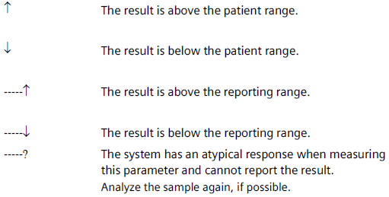
Result Recall | 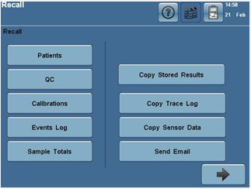  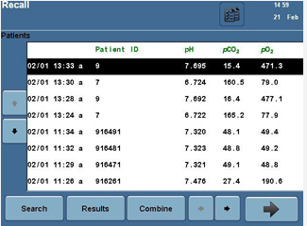    - Log into the analyser and select the ‘tick sheet’ icon in the top right corner  - Select ‘Patients’  - The analyser will display the last 250 patient results.  - Select ‘Search’ to search for a specific patient ID.  - Select ‘Results’ to display the results  - Another copy of the results can be produced by pressing the print icon.  - Log out by selecting the arrow until at the home screen.
Troubleshooting and Incident Reporting | - Sample port - this MUST be replaced when the machine prompts you to do so. The machine has detected a clot and/or an insufficient sample and is unable to analyse the sample. DO NOT attempt to re-run the sample. Ensure that the port is clipped in at both sides; wiggle it to ensure it is fitted securely.  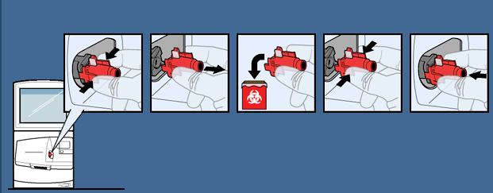  - If the machine displays an error message, please use your nearest alternative analyser and contact POCT. Outside of POCT working hours, follow the Out of Hours Procedure poster behind the analyser.  - Further information, including Standard Operating Procedures can be found at Leeds TH Pathology website.  - When reporting clinical incidents on DATIX, select incidents involving Trust equipment and select ‘in-vitro Medical Devices’ from the drop down list.

